MARKET NOTICE
---
COST OF UNDER-SCHEDULING
ON JUNE 13, 2000

The purpose of this notice is to advise Scheduling Coordinators and other Market Participants of the cost of under-scheduling in the forward markets. In addition to the Hourly Ex Post Price, Scheduling Coordinators are assigned Deviation Replacement Reserve on unscheduled Load. The estimated total cost of each unscheduled MWh of Load based on prices across the June 13, 2000 peak is summarized below:
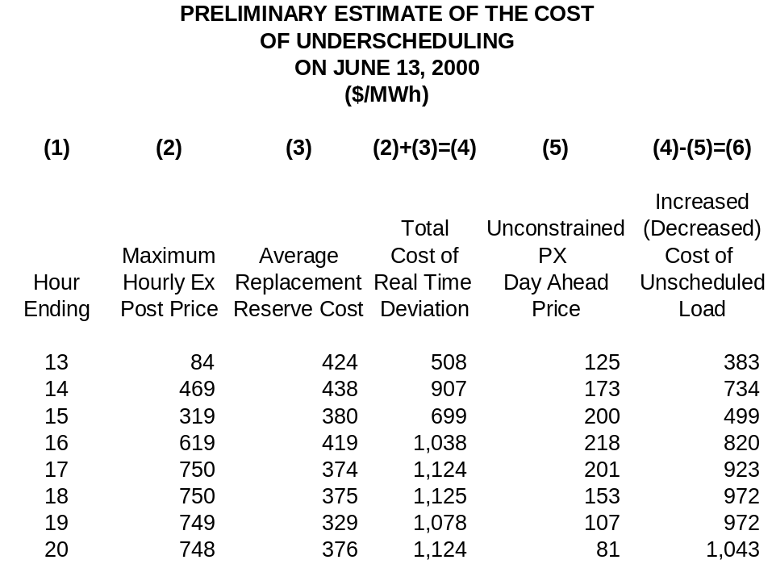

Scheduling Coordinators and other Market Participants may find that their total cost of Energy is reduced by increasing forward market schedules. If the amount of under-scheduling is reduced, then the ISO will need to procure less Replacement Reserve, freeing more supply to compete in forward Energy markets.

